**ECommerce Microservice Explanation**

Sample microservice HLD diagram is as follows :

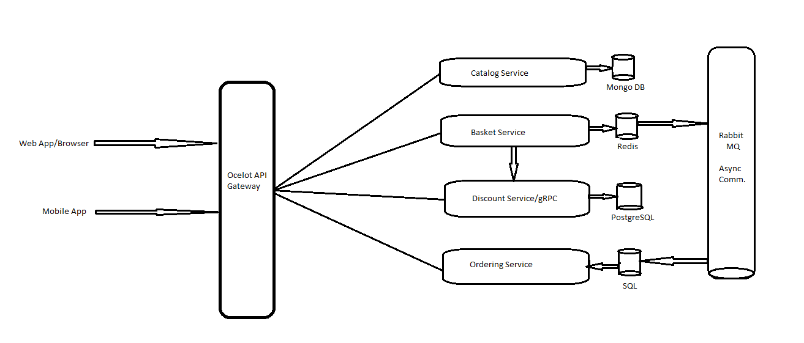

I considered this assignment to be similar to an ECommerce application since UrbanClap works on similar models as that of Ecommerce. i.e. provide services, add to basket, order and checkout.

There are total of 4 services :

* **CatalogService :** This service lists all of the service/products provided by the applicaation based on category and name. It runs on port 8000 in docker environment.
* **BasketService :** This service is responsible for the management of basket/cart. You can add/remove items, increase quantities etc. This service also acts as a **gRPC client** and uses **gRPC communication** to communicate with Discount Service as the price update after applying discount needs to happen immediately. So, it must be a synchronous communication.

* Also, this service also acts as a BasketCheckoutEvent producer and issues basket checkout event to Ordering service using RabbitMQ and MassTransit Event bus. Here I’ve used **Asynchronous communication** between BasketService and OrderingService using **RabbitMQ** and **MassTransit** as checkout process need not to happen immediately. We can wait a little for it. So, I’m pushing it to a queue.It runs on port 8001 in docker environment.
* **Discount Service :** This service is used for calculating discounts on the products/services. This service also acts as gRPC server so that correct gRPC client(basketService in this case) can consume it.It runs on port 8002 in docker environment.
* **OrderingService :** This service is built using CQRS pattern and Domain Driven Design. This service is responsible for final checkout/processing of orders, modifying or deleting the orders. This service also acts as a BasketCheckoutEvent consumer and consumes the BasketCheckoutEvent produced by BasketService for updating order and inventory.It runs on port 8004 in docker environment.
* **APIGateway :**  This service uses an Ocelot API gateway to route the requests to desired service endpoints. This gateway runs on port 8006 on docker environment.